**A Comparison of Countries’ Ecosystem Vitality**

**to Their Reliance on Renewable Sources of Energy**

Elise Lasky, Daniel Rothman, and Alex Tellez

***Introduction.***

Climate change response demands hasty and large-scale reductions in emissions, yet divestment in fossil fuel sources of energy is slow-paced. We wanted to explore this trend as a means of understanding what forces may be impacting this transition to inform national and international climate change policy. While we know that as the price of renewable sources of energy decline, they become more competitive with other sources, we were interested to know if there are other important factors that dictate the movement away from fossil fuels. Because the use of fossil fuels as sources of energy pollutes watersheds and is a significant demand on water supply, it seems plausible that a measure of a country’s quality and quantity of fresh water might be related to its use of renewable energy sources. This research therefore aims to explore if this relationship exists and, if so, to what extent.

***Research Questions.***

The following questions guided our research in understanding the relationship between countries’ reliance on renewables and their freshwater quantity and quality.

1. What countries have a similar level of reliance on renewable energy sources? And what are other attributes of these countries?
2. How much of a country’s reliance on renewable energy sources can be explained by their ecosystem vitality?

***Approach.***

*Data.*

For analysis, we used the most recent country-level data for each variable. For each country, the data set included its percentage of energy from renewable sources, its gross domestic product (GDP), its Ecosystem Vitality Index, and its level of government functioning.

The Ecosystem Vitality Index (EVI) consists of four indicators: water quantity, water quality, basin condition, and biodiversity (Wendling et al., 2018). The index is meant to capture a country’s quality and abundance of freshwater as well as its ability to support water-dependent ecosystem services such as fisheries production, species habitat, wastewater treatment, forest cover, and irrigation.

‘Functioning of government’ is a measurement taken from the Democracy Index, compiled by the Economist Intelligence Unit, which is a UK based company (Democracy Index, 2020). The index is based on a weighted average of the answers to 60 questions, which are grouped into 5 categories, one of which is the functioning of government. This variable allows for the analysis to consider one facet of the Democracy Index, a category that may have influence on whether or not a government has the ability to switch over to renewable sources of energy.

The renewable energy data used was published by the World Bank and is expressed as a percentage of total final energy consumption in a year. In other words, this shows a country’s use of renewable energy as a percentage of their total energy usage in a year.

*Methods.*

To address our first research question, we clustered countries into different numbers of clusters and used different techniques before selecting an appropriate method. Our final method clustered countries into six groups using a partitioning technique. A more detailed explanation of our clustering methods are outlined in the next section.

We answered our second research question through a continuous outcome regression using the explanatory approach. In order to build a model to see if and how much a countries’ reliance on renewables could be explained by their ecosystem vitality, we controlled for GDP and degree of government functioning. A more detailed explanation of our methods is explained in a later section.

***Clustering.***

*Methodology.*

To address our first research question, we clustered countries into six groups using a partitioning technique. After clustering using various techniques--partitioning, agglomerative, divisive, and density-based--we chose to use the partitioning clustering technique because it provided the clearest results with the fewest negative values compared to other techniques (see Figure 1) and created clusters of countries that made logical sense. After clustering countries into progressively more groups, we eventually clustered across six groups, which allowed us to create homogeneity out of heterogeneity.

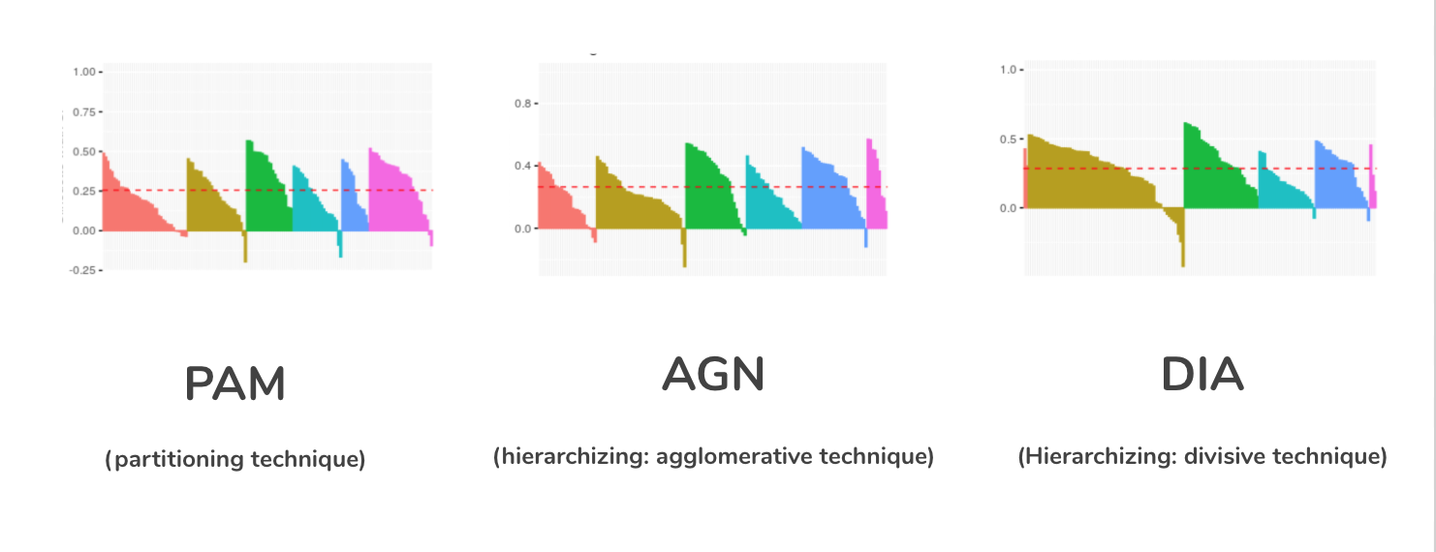

Figure 1. Cluster Silhouettes

*Results.*

After partitioning countries into six clusters, we categorized each cluster based on the range of estimates of each variable in the various groups (see Figure 2).

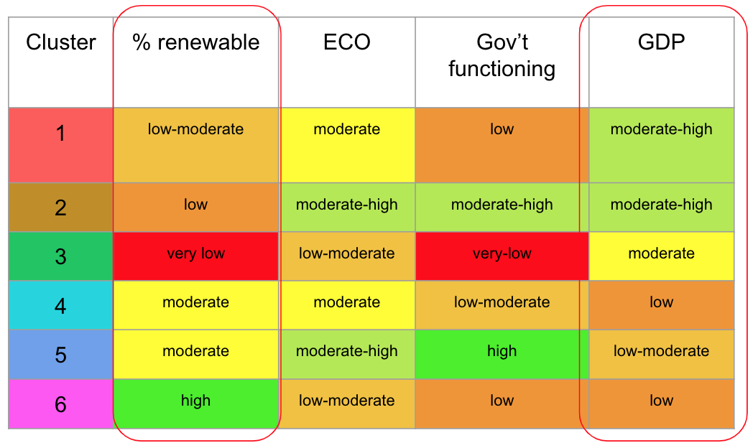

Figure 2. Cluster Categorization

This categorization allowed us to identify the characteristics of each grouping, which are as follows.

1. Countries with lower reliance on renewables and higher GDP, with moderate ecosystem vitality and low functioning government. (e.g. China)
2. Countries with lower reliance on renewables and higher GDP, with higher ecosystem vitality and higher functioning of government. (e.g. The United States)
3. Countries with lower reliance on renewables and higher GDP, with poor ecosystem vitality and very-low functioning of government. (e.g. Russia)
4. Countries with higher reliance on renewables and lower GDP, with poor ecosystem vitality and poorly functioning government. (e.g. Guatemala)
5. Countries with higher reliance on renewables and lower GDP, with moderate ecosystem vitality and moderately functioning government. (e.g. Canada)
6. Countries with higher reliance on renewables and lower GDP, with greater ecosystem vitality and poorly functioning government. (e.g. Haiti)

The color patterns in the columns in Figure 2 begin to demonstrate that there may be a relationship between reliance on renewable sources of energy and a country’s ecosystem vitality, GDP, and functioning of government. The columns circled in red in Figure 2 indicate that there is both an inverse relationship between GDP and reliance on renewable sources of energy. Other patterns indicate a relationship between ecosystem vitality and reliance on renewable sources of energy. In order to further investigate this relationship and answer our second research question, we performed regression analysis.

***Regression Analysis***

*Methodology.*

Our methodology for our linear regression analysis was to use a simple model to measure the impact of ecosystem vitality on a country’s use of renewable energy sources. However, since there may be confounding variables that are biasing the effect of the independent variable in our simple model, we introduced controlled-for variables to our model, one by one, to generate a more accurate estimate. This also enables us to separate the impact of the controlled-for variables from the effect of a country’s ecosystem vitality. While this type of multiple linear regression model can help reduce omitted variable bias, it is by no means comparable to a controlled experiment with a true counterfactual. As such, this model may be oversimplifying the truth and any recommendations must take into consideration this limitation.

The three regressions we performed included:

1. a comparison of countries’ percentage of energy from renewables to their ecosystem vitality
2. a comparison of countries’ percentage of energy from renewables to their ecosystem vitality controlling for GDP
3. a comparison of countries’ percentage of energy from renewables to their ecosystem vitality controlling for GDP and functioning of government.

Our hypotheses for the final regression are as follows:

**Null Hypothesis:**  b1 = 0 → Controlling for GDP and the functioning of a country’s government, a country’s use of renewable resources of energy cannot be explained by its ecosystem vitality index.

**Alternative Hypothesis:** b1≠ 0→ Controlling for GDP and the functioning of a country’s government, a country’s use of renewable resources of energy can be explained by its ecosystem vitality index.

These hypotheses were born out of the rationale that countries with less ecosystem vitality, or ability to deliver water-related ecosystem services, have more reason to switch to renewable sources of energy to preserve their natural resources.

*Regression Results.*

The results of the first regression (see Figure 3 below) estimate that with an increase in ecosystem vitality index by one unit, a country’s reliance on renewable energy is lower by .76 percent. This means that the higher the country’s capability to deliver water-related ecosystem services; the lower their commitment to renewables. While this coefficient decreased as control variables were added, the trend remains the same. The final regression, which includes the two additional control variables, leads to the rejection of the null hypothesis in support of the alternative hypothesis. Controlling for GDP and the functioning of countries’ governments, a country’s use of renewable sources of energy can be explained by its ecosystem vitality index.

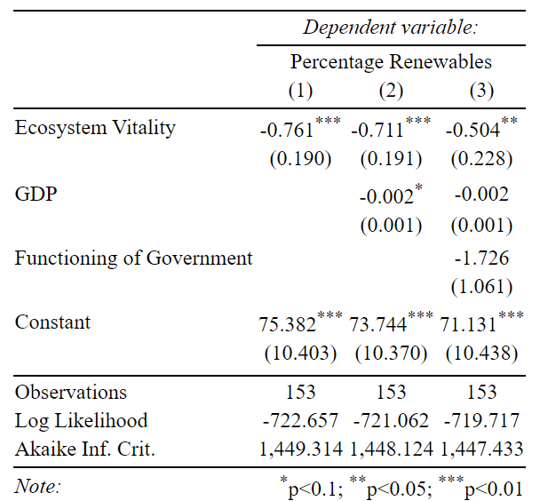

Figure 3. Regression Models

*Regression Analysis Diagnostics.*

To test the underlying assumptions in our linear regression model, we used a Residuals versus Fitted plot for our final regression model. As you can see in Figure 4, the residuals are randomly situated around the “0” line which corresponds to the estimated regression line. This suggests that the variance of the error terms are equal and that a linear relationship is reasonable.

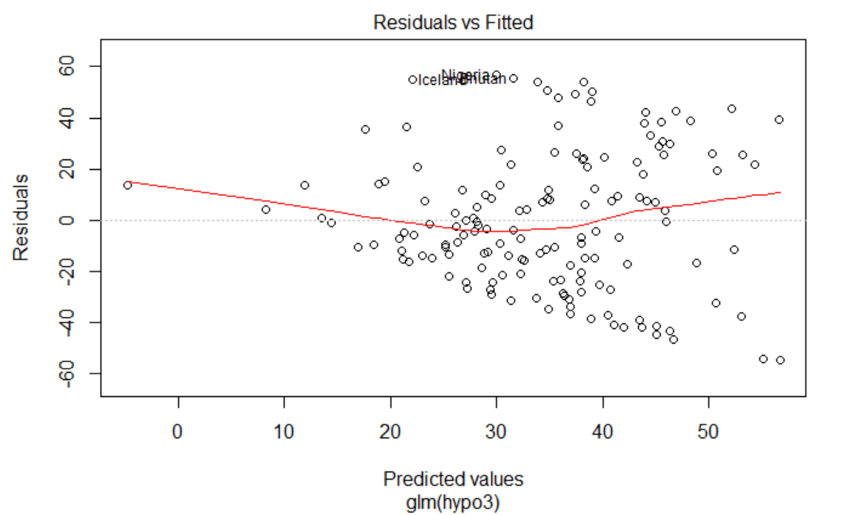

Figure 4. Residuals versus Fitted Plot

However, we noticed that our residuals plot looked heteroskedastic, so we conducted a Breusch–Pagan test to test for heteroskedasticity. Our test statistic had a p-value <0.05 so the null hypothesis of homoscedasticity is rejected and heteroskedasticity is assumed. The presence of heteroskedasticity presents a challenge to the precision of our estimated coefficients and also means that our p-values may be underestimated.

A Q-Q plot for our final regression model in Figure 5 seems to indicate that observations in our sample are normally distributed, as the data points roughly form a straight line. However, we conducted a Shapiro-Wilk Test to test if our sample was normally distributed. Our test statistic had a p-value < .01, which indicates that our sample is not normally distributed. Since Ordinary Least Squares regression analysis does not require that the error term follow a normal distribution to produce unbiased estimates, the only limitation this presents would be less reliable confidence intervals around our point estimate.

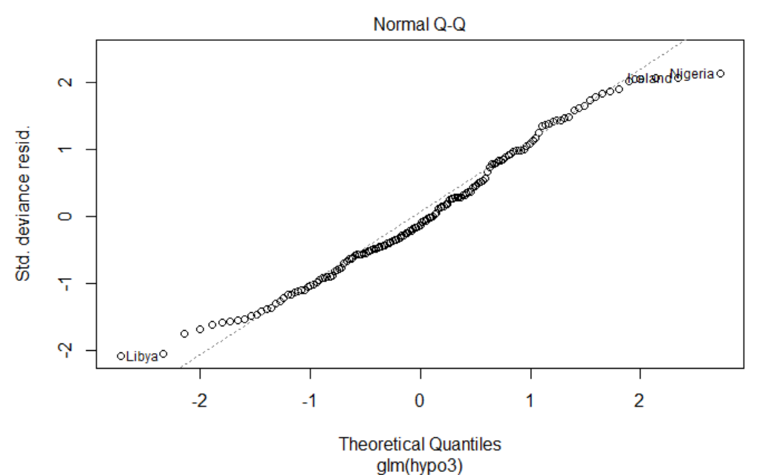

Figure 5. Normal Q-Q Plot

The Residuals vs Leverage plot in Figure 6 helps us determine influential outliers that may alter the results if they were excluded from the model. The only country of concern is the United States; however, it is within the Cook’s distance lines so we determined that it wouldn’t have made a discernable impact on our regression results if it were to be excluded.

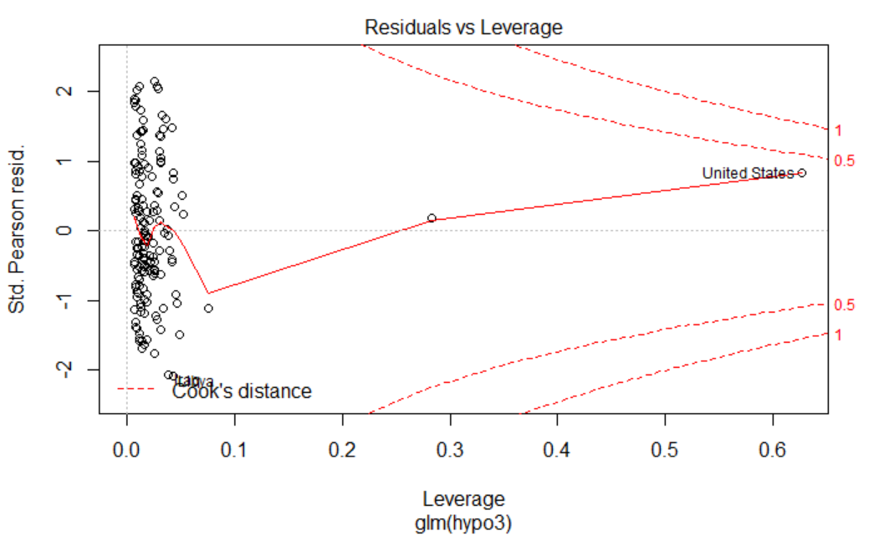

Figure 6. Residuals versus Leverage Plot

The forest plot in Figure 7 is a visual representation of our final regression model that controls for GDP and the functioning of government. The data point on the chart represents the estimated impact the independent variable has on a country’s commitment to renewable energy. Figure 7 shows that GDP has a minimal impact on the dependent variable in our model. Additionally, the confidence interval around the estimated effect of a country’s functioning of government on their commitment to renewable energy includes “0”. This means that a country’s functioning of government could either have a positive or negative impact on their commitment to renewable energy. While these control variables may not be suitable for this regression model, we are confident that a country’s ecosystem vitality has a negative effect on a country’s commitment to renewable energy. A future model should look to include confounding variables that have a more precise impact on our dependent variable.

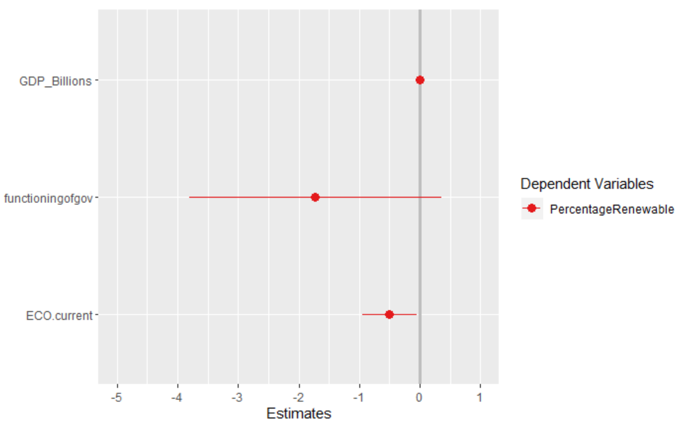

Figure 7. Forest Plot

*Discussion.*

At face value, our results are compelling. Hypothetically, a country with low quality and abundance of water might have more pressure to switch to renewables so they can relieve stress on aquifers or because there is a limited supply of water.

Our p-value of less than 0.05 for our final regression model tells us that a country’s ecosystem vitality has a significant effect on its commitment to renewable energy. While our R-squared value of 0.113 is rather low and indicates a lot of variability in our model, our model is explaining 11% of that variance which is quite significant considering we did not control for other confounding variables that we imagine may also impact a country’s dependence on renewables for energy.

While our model is compelling, problems in the variance of the residuals and the fact that our observations are not normally distributed challenges the precision of our coefficients and confidence intervals. The model would have to be refined before definitively claiming that a country’s dependence on renewables for energy can be explained by its ecosystem vitality index.

*Recommendations.*

After seeking a refined model and gaining reassurance of the negative relationship between ecosystem vitality index and reliance on renewable, we would begin to make recommendations. Assuming that this relationship can be substantiated, we recommend the following broad strategies to encourage investments in renewable energy.

1. Develop tax credit programs and grants for protecting biodiversity and water quality.
2. Disincentivize the use of non-renewable sources of energy through taxes on energy producers for water use.
3. Improve regulatory water quality protections.

These strategies would theoretically drive private and public organizations to switch from fossil fuels to renewables by either increasing the price of freshwater resources (an input for non-renewable energy production) or by lowering costs to switching to renewable energy through a financial mechanism that generates value from biodiversity and water quality.

References

Democracy Index. (2020). In Wikipedia.

[https://en.wikipedia.org/w/index.php?title=Democracy_Index&oldid=943791](https://en.wikipedia.org/w/index.php?title=Democracy_Index&oldid=943791006)

[06](https://en.wikipedia.org/w/index.php?title=Democracy_Index&oldid=943791006)

GDP (current US$) | Data. (n.d.). Retrieved March 4, 2020, from

<https://data.worldbank.org/indicator/NY.GDP.MKTP.CD?view=chart>

Renewable energy consumption (% of total final energy consumption) | Data.

(n.d.). Retrieved March 4, 2020, from

<https://data.worldbank.org/indicator/EG.FEC.RNEW.ZS?view=chart>

Wendling, Z. A., Emerson, J. W., Esty, D. C., Levy, M. A., de Sherbinin, A., *et al*. (2018). *2018 Environmental Performance Index*. New Haven, CT: Yale Center for Environmental Law & Policy. <https://epi.yale.edu/>